# slp Requirement

We need to be able to select a date x day's in the future in order to grant an extension for x days.

Closure days and weekends should not be included in this.

Closure days are held within the HLD table.

# Solution

We need to iterate through the next couple of weeks and remove any invalid days. This is done by using a UDV/UDD called "count" with a collection of UDDs ranging from 01 - 20.

We will run a get list of this collection of UDDs and then do a calculation with the value.

Todays date PLUS the UDD value.

This should give us a list of the next 20 days in date format.

We then need to check each of these dates against HLD. If it is present, don't include it in our output as it is invalid.

Finally, with the remaining dates, we need to check if they are a Saturday or a Sunday. Check this by formatting as &DD3 (to get the english day name) and checking it isn't Sat or Sun (otherwise exclude it from the output).

Append any returned value with a ~ (important for the next step).

Finally, with the returned list, run an extract based on the ~ delimeter and select the xth value.

You pass in a temporary variable <<#DATE>> as a start date. To run as today just enter: <<#DATE=&$DATE>>

So if you need a day 5 days from now (excluding closure days and weekends) you would run <<#DATE=&$DATE>><<@NON-HLD-WKND&E5(~)>>

# Technical Implementation

## UDV/UDD: UDV_CODE = COUNT

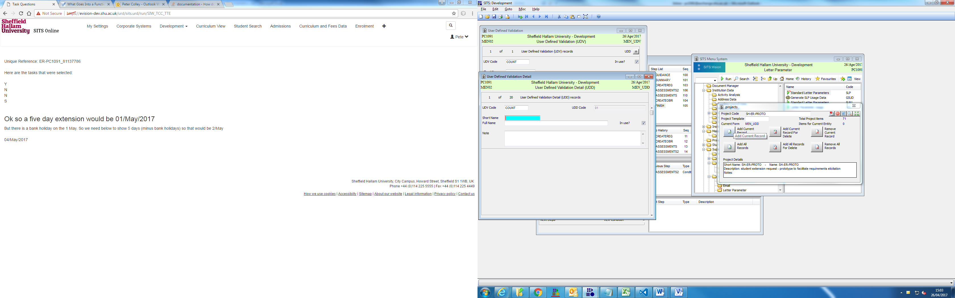

## Get iterator SLP: @NON-HLD-WKND

<<"UDD_UDVC=COUNT·;FORCEALLFIELDS=Y·;SORT=UDD_CODE"&G@NON-HOLIDAYS>>

## Check HLD: SLP: @NON-HOLIDAYS

[UDD.MENSYS:<<#DATE2=<#DATE>&D+<UDD_CODE>D>>{{SEL:("<<HLD_DATE=<#DATE2>·;COUNTONLY=Y&GHLD_HLCC.HLD.CAMS>>"="0"):<<@NON-WEEKENDS>>}}]

## Check non-weekend: SLP: @NON-WEEKENDS

{{SEL:("<<#DATE2&DD3>>"!="Sat" & "<<#DATE2&DD3>>"!="Sun"):<<#DATE2>>~}}